# EA-467 Spacecraft EPS Lab (Part 2: IV Curves and Regulators) (rev-c) Fall 2017

**Elements**: Solar panel IV curves, temperature effects, Series, DC/DC and Shunt Regulators

**Introduction:**

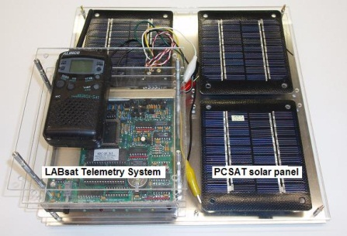In parts A and B last lab period, you learned about the charging/discharging of a spacecraft battery. This period you will add a solar panel to your telemetry system and observe the IV curve, the temperature effect and also the function of voltage regulators. The next lab in the series is the LABsat EPS design challenge (LABsat configuration shown at right) where you must design a solar array system to power your LABsat, using manufacturer-provided IV curves to help you select from a number of solar panels for your design.

As in the telemetry labs, your LABsat (Arduino) will output its telemetry via its USB port to your PC’s Arduino serial viewer. You will conduct experiments to observe the following:

1. 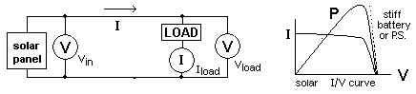Solar panel current-voltage (I-V) and power curves
2. Series, DC/DC switching, and Shunt Regulators
3. Temperature effects on solar panels

**Part C. Solar Panel I-V Characteristics:**

You are familiar with common power supplies or batteries that have a relatively fixed voltage (12v, 115v, etc.) under various loads as shown by the steep dotted line on the I-V curve above. Solar panels, 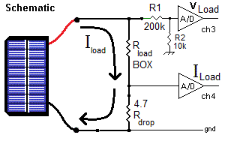however, have a limited current and an output voltage that is not constant but is dependent on the incident energy, the load, the internal impedance of the panel, and the temperature of the panel. The resulting limits on source voltage and current due to changing loads are usually described by an I-V curve as shown above. This experiment will derive the IV curve for a solar panel using your Arduino telemetry system as shown in the schematic here, with the V and I being reported by your CH3 and CH4 telemetry.

1. Check that your LABsat is wired as shown here. Turn it on and load your TelemetryII code with a delay parameter set so that you are seeing the telemetry stream updated about once every second. Do not use the engineering unit conversion equations, assume the output is calibrated to read volts*10 (i.e. a count of 80 is 8.0 volts) and current in mA as in the telemetry lab.
2. 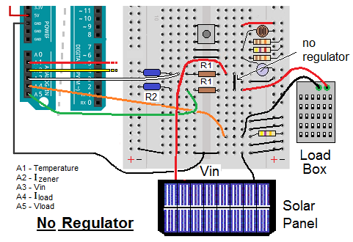Notice the load resistor from the TelemetryII lab has been replaced with taps over to the Resistor Box. The solar panel is connected with its + output supplying power to the top of the load resistor (and sampled by your R1/R2 voltage divider telemetry circuit) with the – side connected to ground.
3. Notice there is a small jumper at the junction of the R1 and the solar panel and load box. We will replace this later with a 5v voltage regulator.
4. Read step 5 and think about how you will do each step and record the data so that you don’t have to leave the lamp on very long and overheat the panel. When ready, align your solar panel on the end of your lamp stand, turn on your lamp and begin to take data.

1. With the lamp on, record the voltage (channel 3) and current (channel 4) for each of the following loads (set via the Load Box): 3000, 2000, 1000, 700, 400, 300, 250,220,180,140,100,70,50,40, 20 and 0  (note: make sure to wait at least the length of the sampling interval before taking data). Record the Channel 3 (V) and Channel 4 (I) data for each of the resistor loads. It is recommended that you then turn off the lamp for 30secs after each 3 data points you record to avoid the solar panel temperature from raising too quickly, which will alter your data as seen in Part G. Enter your data into Excel as you go, plotting current (y-axis) vs voltage (x-axis), so that you can see the validity of your data during the lab while you still have time to fix it.
2. **Post-Lab:** Plot current in mA and power in mW (plot power on the secondary y-axis to achieve proper scaling). Identify the peak power point for your panel. Your plot should look similar to the sketches in this lab on page 1.

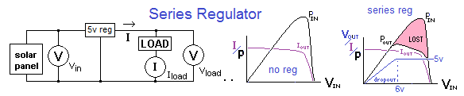

**Part D. Series Voltage Regulation:** Since electronics generally require fixed voltages, while the solar array voltage output (I-V curve) varies according to the load, voltage regulators are used to maintain constant voltages for the electronics and charge regulators ensure proper currents for battery charging. The most common *series regulator* provides a constant output voltage by dropping excess voltage internally. This internal voltage drop wastes power proportional to the current as hashed in pink above. Although this is most inefficient at high current loads, its primary advantage is that it wastes the least power under small loads which is the most common situation terrestrially (doesn’t waste power when not in use).

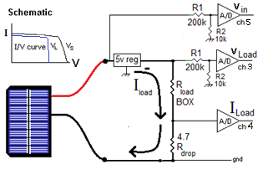The block diagram above represents the series regulation circuit diagram. The figure below shows how the jumper in the previous section has been replaced with a small 3 terminal 5-volt regulator. Also, we have added the 5th voltage telemetry channel on the A5 input to the Arduino to now read the load voltage.

Channel 3 will continue to read the solar panel input voltage via R1/R2.

Channel 4 will continue to read the Load current as the voltage drop across Rdrop (4.7 ohms).

Channel 5 will read the Load voltage using another R1/R2 combo (193k and 10k).

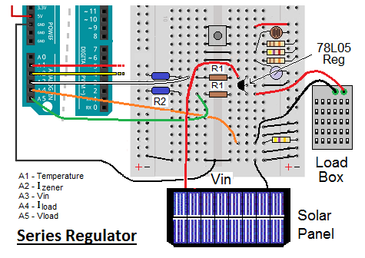

1. Record data from channels 3-5 for the following load resistance values: 2000, 1000, 700, 400, 300, 250, 220, 180, 140, 100, 70, 50, 40, 10 and 0   Turn off the lamp for 30 seconds after each 3 data points to prevent overheating.
2. Enter your data into Excel in raw count for channels 3 through 5 (i.e. Vin, Iload, Vload). Now generate new columns for Vin(volts) (to be the X axis) and Vload(volts) using the 0.1 factor telemetry equation. The currents will remain in mA.
3. **Post-Lab:** Generate four new columns for Pin - input power (Vin * Iload), Pload - load power (Vload * Iload), Preg - regulator power (Vin - Vload) * Iload, and Efficiency (Pload/Pin)*100. Plot these four, as well as Iload and Vload, against input voltage (Ch3) (X axis). Scale the values and use both primary and secondary axes to appropriately plot all of these on the same graph. Note the peak power points. Comment on the differences in the I-V curve for the series regulated load and the unregulated I-V curve. Over what input voltage range does the regulator maintain 5 volts output (+/- 10%). What is the efficiency of this series regulator at the load’s peak power point compared to the original I-V solar panel’s peak power point? Compare differences to the Shunt and DC/DC regulators (Parts E and F).

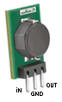

**Part E. DC/DC Voltage Converters:**

Replace the 3-terminal series regulator with the more efficient 3 terminal DC/DC converter/regulator. The problem with series regulators is that they waste power dropping the voltage from Vin down to the regulated Vout while the current remains the same. So the power wasted in the regulator transistors as waste heat is simply the current times the voltage dropped which can be 50% or more.

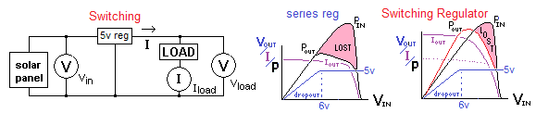

In contrast, the modern DC/DC regulator can operate at efficiencies well above 90%. Instead of “dropping” voltage across a transistor, the DC/DC converter chops it into a high frequency pulsating DC and uses the duty-cycle to establish the output voltage. For example, a 50/50 duty cycle pulse train when filtered has an average DC voltage that is half of the input voltage. This is very efficient because the switching transistors are either fully ON (near 0 volts across them), or fully OFF (0 current through them), so the power wasted in the transistor (I*V) is much smaller than in the series regulator transistor which is dropping all the difference.

**Repeat the steps of Part D** using the 3-terminal DC/DC regulator.

**Post-Lab:** After accumulating the data, look at the data point of the maximum power delivered to the load. [I load * Vload].

**Part F. Shunt Regulation:**

Shunt regulators regulate voltage by dumping (shunting) excess current into a resistive load. A simple Shunt Regulator is simply a Zener diode which has an I-V characteristic as shown above right. In the 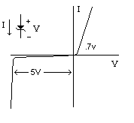forward direction, it passes current like any diode above its turn-on threshold (about 0.6 volts). In the reverse direction (as normally used), it passes no current until its “Zener” threshold. At that voltage threshold it begins to conduct all excess current to regulate the circuit at that voltage.

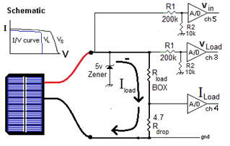

The advantage of a shunt regulator is its simplicity and the absence of any series voltage drop under heavy loads. Thus, it can provide maximum power to the load with the least loss, as opposed to the series regulator which has maximum loss under peak load. Its disadvantage is that at all power levels below that peak, it has to conduct and completely waste all excess power available that is not used by the load. Thus it is ***never*** used terrestrially where energy has costs.

In space, however, the shunt regulator is widely used because the power (solar) is free, or more correctly, has already been paid for. So it costs nothing to simply throw away excess power or use it for mundane applications such as thermal heating when the regulator has excess power. Thus the heat dissipation of the shunt regulator must be accounted for by the thermal control subsystem and can often be used to advantage.

1. 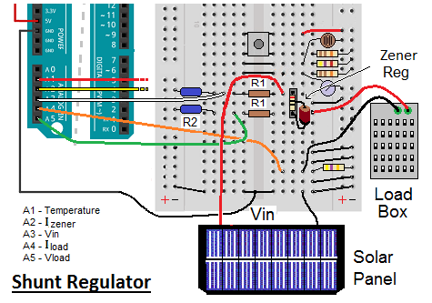For comparison between series and shunt regulators, Note the Part E and Part F resistance values that gave the peak power points.
2. Now use the image above right to replace the DC/DC converter with the Zener diode module as shown.
3. Turn on the light and record the Iload and Vload telemetry for only the load resistor values of 140, 100, 70, 50, 40, 30 and 20
4. **Post-Lab:** Compare the peak power near 4.5 volts compared to the other regulators for your report. It should be higher since at peak current, there is no power being lost in the regulator.

**Part G. Temperature effects:** Temperature has a significant negative effect on the voltage output of the cells and a smaller positive effect on current. The net combined effect is thus degraded power output. Spacecraft design should include thermal design of the panels to keep them as cool as possible. We have placed an Arduino configured for telemetry as beforein the thermal chamber exposed to a sun lamp and operated it over a temperature range from approximately -20 to + 80C. The data from the Arduino in the chamber was transmitted to the lab and imported into Excel. Download the “EPS-Part C-thermal-data” file from Blackboard and save it to your own drive with a new filename.

Convert the temperature count (X) to degrees C using the engineering unit conversion equation developed in the last lab: T = 2.18e-5 X3 - .00775 X2 + 1.2 X – 46.8

Plot the voltage and current versus temperature to see the effect of heating (plot current on the secondary axis to achieve proper scaling). Plot power versus temperature as well (scaled properly for viewing on the same graph) to see if power is degraded with increasing temperature.

**Laboratory Report:**

This section of the EPS lab will be combined with the EPS Battery lab and the next EPS Design Exercise into a laboratory report similar to what you have done on previous labs, following your instructor’s guidelines.

Added parts to Arduino Board from Telemetry Lab:

4.7 ohm Rdrop

10k R1 for Voltage Divider2

200k R2 for Voltage Divider2

Series Regulator

Zener regulator

Switching Regulator